Abstract Advancing Satellite Imagery Analysis Object Detection For Precision Mapping

Abstract
Object detection in satellite imagery is vital for numerous applications, including urban planning, environmental monitoring, and defense. This project aims to enhance object detection accuracy and efficiency by utilizing the DOTA (Dataset for Object Detection in Aerial Images) dataset, known for its complexity and diversity. We propose a system based on YOLOv8, a cutting-edge object detection architecture, integrated with tiled inference to manage high-resolution aerial images effectively. The system is designed to overcome challenges in detecting small, rotated, and overlapping objects in complex scenes. By implementing advanced preprocessing and leveraging YOLOv8’s speed and accuracy, our solution achieves real-time object detection performance suitable for precision mapping. Performance is evaluated using metrics such as mAP50, ensuring robust and scalable results for large-scale satellite image analysis.

Introduction
In recent years, satellite imagery has become a cornerstone in applications requiring geospatial intelligence. From agriculture to defense, accurate object detection within aerial images is essential for making informed decisions. However, satellite imagery introduces challenges like high image resolution, object rotation, scale variation, and complex backgrounds. The DOTA dataset is a benchmark in aerial object detection but poses significant challenges due to its variety of object classes and dense scenes.
Traditional object detection models, while effective in simpler environments, often fall short when applied to such complex data. This project proposes an enhanced approach by incorporating YOLOv8, a recent evolution in the YOLO family, and tiled inference, to provide precise, real-time detection of objects in high-resolution aerial images.

Aim
To develop an advanced object detection system using YOLOv8 and tiled inference for efficient and accurate analysis of satellite imagery in the DOTA dataset.

Scope
- Satellite-based surveillance and monitoring.
- Urban and rural development analysis.
- Disaster management and response.
- Military and defense applications.
- Agricultural field mapping and monitoring.

Objectives
- To implement and train the YOLOv8 model on the DOTA dataset.
- To apply tiled inference for handling high-resolution aerial images.
- To perform preprocessing techniques like annotation rotation, image normalization, and augmentation.
- To evaluate model performance using mAP@50, precision, and recall.
- To enable real-time detection capabilities for large-scale applications.

Challenges
- Handling large and high-resolution images in satellite data.
- Accurate detection of small, rotated, or overlapping objects.
- Ensuring real-time processing speed without sacrificing accuracy.
- Managing class imbalance in the DOTA dataset.
- Optimizing tile merging to avoid duplicate detections or missed objects.

Literature Survey
- DOTA Dataset (Xia et al., 2018): One of the most comprehensive datasets for object detection in aerial imagery, featuring oriented bounding boxes and 15 object categories. Known for its complex scenarios.
- YOLO (You Only Look Once): Introduced as a unified model for real-time object detection. Successive versions (YOLOv3 to YOLOv7) improved accuracy, speed, and model compactness.
- YOLOv8: A more robust and modular architecture from Ultralytics. Offers better accuracy and flexibility for deployment, with improved backbone and neck for feature extraction and fusion.
- Tiled Inference (Cheng et al., 2020): Demonstrated how tiling large images into manageable sections enhances detection performance in high-resolution aerial datasets.
- FPNs and Multi-scale Approaches: Feature Pyramid Networks and similar architectures have shown the importance of detecting objects across scales.

Existing System and Disadvantages

Existing System:
Most existing systems use earlier YOLO versions or other object detectors (e.g., Faster R-CNN, SSD) directly on the DOTA dataset. While these models achieve moderate success, they often:
- Fail to detect small or rotated objects.
- Suffer from slow inference due to high-resolution imagery.
- Lack efficient mechanisms to process large images effectively.

Disadvantages:
- Low accuracy in dense scenes.
- High computational cost and memory usage.
- Inability to process images in real time.
- Poor performance on rotated bounding boxes.

Proposed System and Advantages

Proposed System:
Our system integrates:
- YOLOv8, offering high accuracy and low latency.
- Tiled inference, which breaks large satellite images into smaller tiles for parallel and scalable detection.
- Preprocessing methods for oriented bounding boxes and data augmentation tailored to aerial imagery.

Advantages:
- Enhanced detection of small, rotated, and overlapping objects.
- Improved real-time performance through parallelized tiled inference.
- Scalable solution for high-resolution aerial images.
- Greater accuracy and precision, suitable for large-scale mapping.

Project Methodology and Working

1. Data Preparation:
- Load and convert DOTA dataset annotations (oriented bounding boxes) into YOLOv8-compatible format.
- Apply augmentations: rotation, flipping, brightness adjustments.
- Normalize and resize images while preserving spatial information.

2. Tiling and Preprocessing:
- Split large images into smaller tiles (e.g., 1024×1024).
- Add overlap margins to prevent object truncation.
- Track tile positions for post-inference merging.

3. YOLOv8 Integration:
- Customize YOLOv8 configuration for aerial image detection.
- Train the model using transfer learning (pretrained weights on COCO or custom aerial datasets).
- Fine-tune for mAP@50 performance.

4. Inference and Merging:
- Perform inference on each tile.
- Map detections back to original coordinates.
- Apply Non-Maximum Suppression (NMS) to remove duplicates across tile borders.

5. Evaluation:
- Use metrics such as mAP@50, mAP@75, precision, recall.
- Compare against baseline models (YOLOv5, Faster R-CNN).

Technologies Used (in Detail)
- YOLOv8 (Ultralytics):
  - Python-based object detection model.
- Python Libraries:
  - PyTorch: For training YOLOv8.
  - Albumentations: For data augmentation.
  - OpenCV: For image processing and tiling.
  - NumPy, Pandas: For data manipulation.
  - Matplotlib/Seaborn: For visualizing metrics and detections.
- DOTA Dataset:
  - Aerial images with annotations in rotated bounding boxes.
  - Requires conversion to YOLO format and rotation-aware handling.

Future Scope
- Integrate rotated object detection heads for improved accuracy.
- Deploy the model in edge computing environments (e.g., drones, satellites).
- Extend the system to include semantic segmentation.
- Use temporal data from satellite time series for change detection.
- Build a web-based dashboard for interactive satellite image analysis.

Conclusion
This project presents a robust object detection framework for satellite imagery using YOLOv8 and tiled inference, tailored for the DOTA dataset. It addresses the limitations of traditional approaches by enhancing both accuracy and processing speed. Through preprocessing, intelligent tiling, and state-of-the-art model architecture, the system is capable of high-performance detection in complex aerial scenes, making it suitable for real-world applications in precision mapping and geospatial intelligence.

System requirement

Software Requirements:
Python 3.9 or >
All the OS which can afford python 3.9 or > like windows 10, mac os, etc
Vs code (Visual studio)
Necessary python modules

Preferred Hardware Requirements:
Processor: Intel i5 eq or better
RAM: 16 GB or more
OS: Windows 10 or 11, MacOS Monterey or Newer
Storage (SSD Only): 128 GB or more (Minimum 32 GB Free)

FLOW chart:
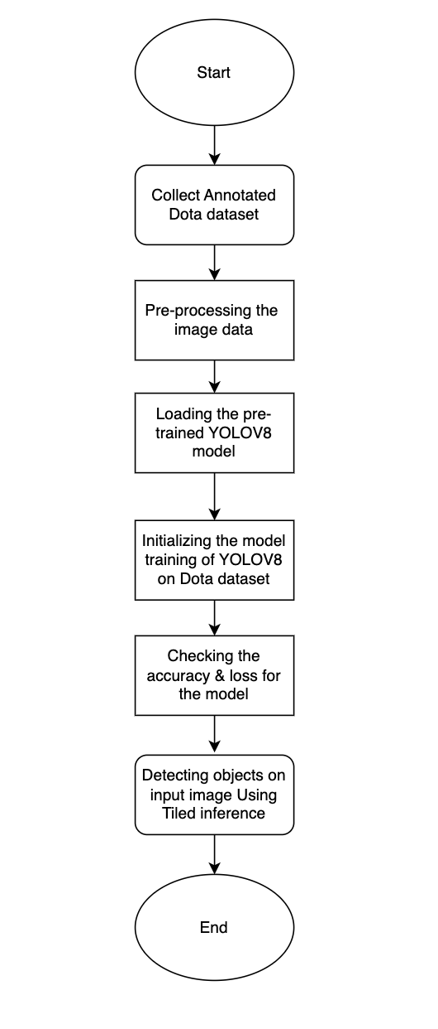

Data Analysis Techniques
To evaluate and interpret the performance of the proposed object detection system, the following data analysis techniques will be employed:

1. Exploratory Data Analysis (EDA)
- Class Distribution Analysis:
  - Analyze the frequency and distribution of object categories in the DOTA dataset.
  - Identify class imbalance issues.
- Object Size and Orientation Analysis:
  - Measure the pixel size and angles of annotated objects.
  - Identify how object dimensions affect detection accuracy.
- Scene Complexity Evaluation:
  - Assess image complexity by calculating object density per image.

2. Image Tiling Analysis
- Tile Overlap vs Accuracy:
  - Experiment with different tile sizes and overlaps (e.g., 512×512, 1024×1024, with 10–20% overlap).
  - Analyze how overlap affects duplicate detections and boundary truncations.

3. Training Performance Metrics
- Loss Curves:
  - Plot and analyze classification loss, localization loss, and total loss over epochs.
- Learning Rate Finder:
  - Use automated LR tuning to determine the optimal learning rate for YOLOv8 training.

4. Evaluation Metrics
- Mean Average Precision (mAP):
  - Primary metric, especially mAP@50 and mAP@[.5:.95], to assess detection accuracy.
- Precision & Recall:
  - Precision = TP / (TP + FP) — indicates how accurate the detections are.
  - Recall = TP / (TP + FN) — indicates how many true objects are detected.
- F1 Score:
  - Harmonic mean of precision and recall to balance the two.
- IoU (Intersection over Union):
  - Used during evaluation to determine detection correctness by comparing predicted and ground truth bounding boxes.
- Confusion Matrix:
  - For each class, track true positives, false positives, and false negatives.

5. Inference Time Analysis
- Measure:
  - Inference time per image (standard vs. tiled).
  - GPU memory usage and CPU load.
  - Frames Per Second (FPS) for real-time feasibility.

Expected Results
The expected outcomes of the proposed system are as follows:

1. Improved Detection Accuracy
- The YOLOv8 + tiled inference approach is expected to outperform previous YOLO versions and conventional detectors (like Faster R-CNN) in terms of:
  - Higher mAP@50 (target: >75%)
  - Better detection of small, rotated, and densely packed objects.
  - Increased class-wise precision and recall.

2. Efficient Real-time Performance
- With tiled inference and YOLOv8's architecture:
  - Achieve inference speeds of >20 FPS on high-end GPUs (e.g., RTX 3080+).
  - Support real-time or near-real-time satellite image analysis.

3. Better Handling of Large Images
- With tiling and overlap strategies:
  - Minimized boundary artifacts and improved edge detection.
  - Efficient scaling for large-format images without excessive GPU memory demands.

4. Robust Model Generalization
- With data augmentation and careful preprocessing:
  - High generalization ability to new unseen aerial images from similar domains.
  - Low overfitting on validation datasets.

5. Quantitative Insights
- Detailed class-level performance reports.
- Visual analytics: side-by-side comparison of ground truth vs predictions.
- Graphs of loss, precision, recall, mAP over epochs.

Reference papers:

https://ieeexplore.ieee.org/document/8122799
https://ieeexplore.ieee.org/document/10808576
https://ieeexplore.ieee.org/document/8868462
https://ieeexplore.ieee.org/document/10147590
https://ieeexplore.ieee.org/document/9388517
https://ieeexplore.ieee.org/document/5370138
https://ieeexplore.ieee.org/abstract/document/10890247

